**SQL Queries**

**Table-1**

1 Write a query to **Retrieve the Top 20  Most Expensive Products.**

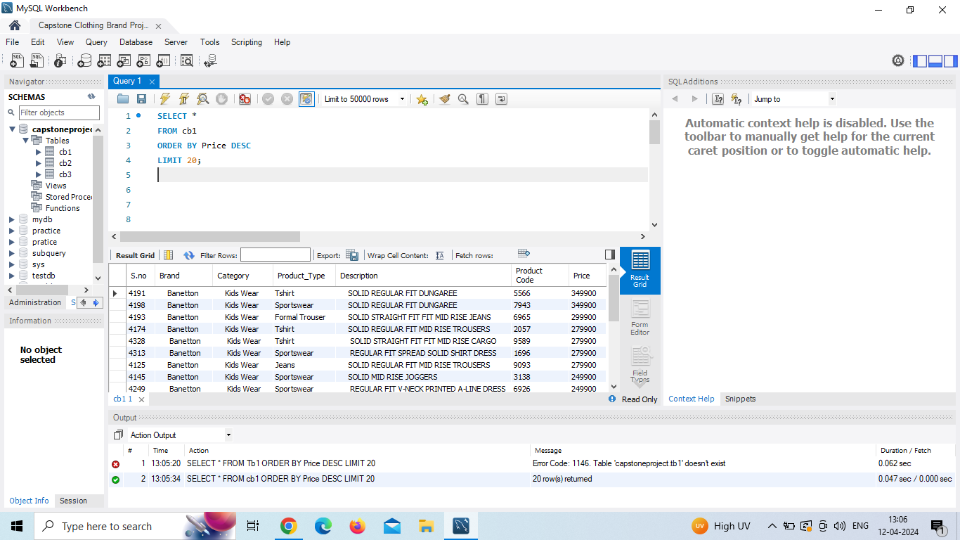

2. Write a query **Calculate the Total Price for Each Category**:

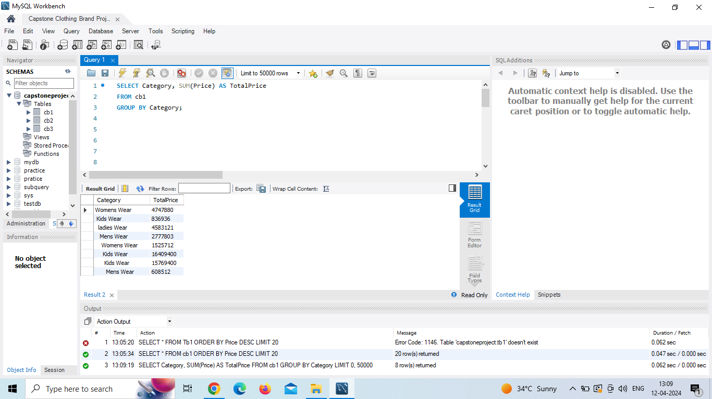

3. Write a query to **Retrieve Products with a Price Range** 2000 to 5000

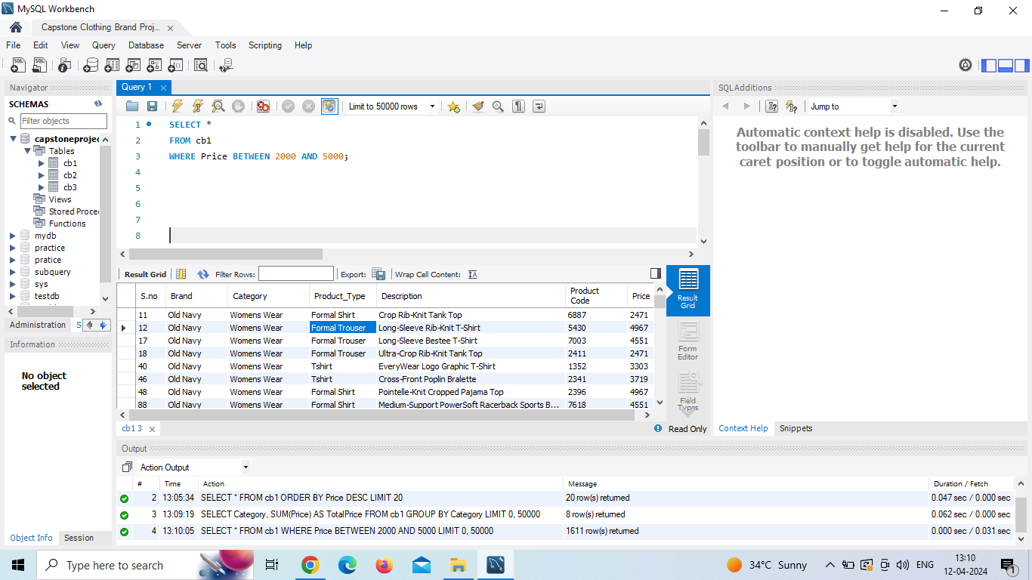

4. Write a query to **Calculate the Average Price for Each Brand .**

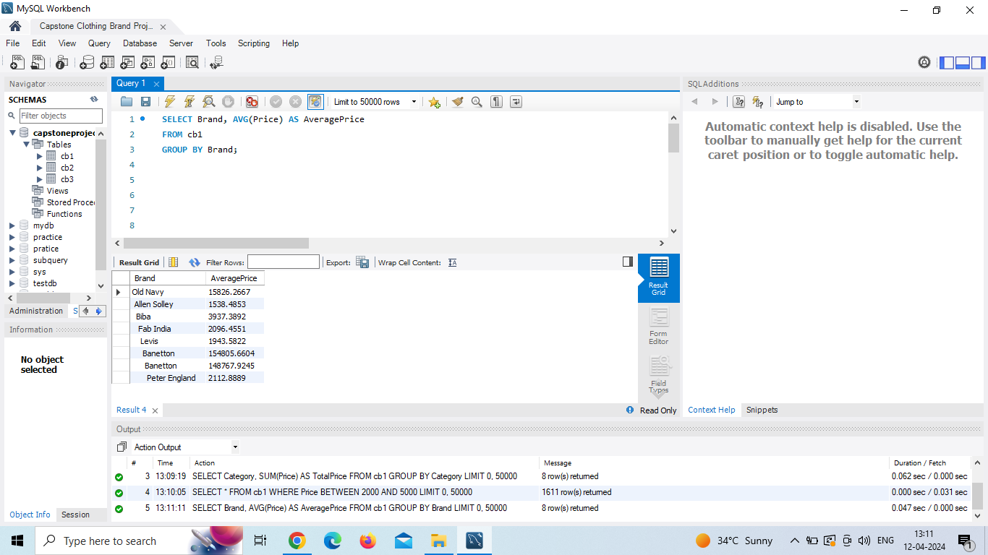

5. Write a query to **find Products with Unique Brand-Category Combinations**

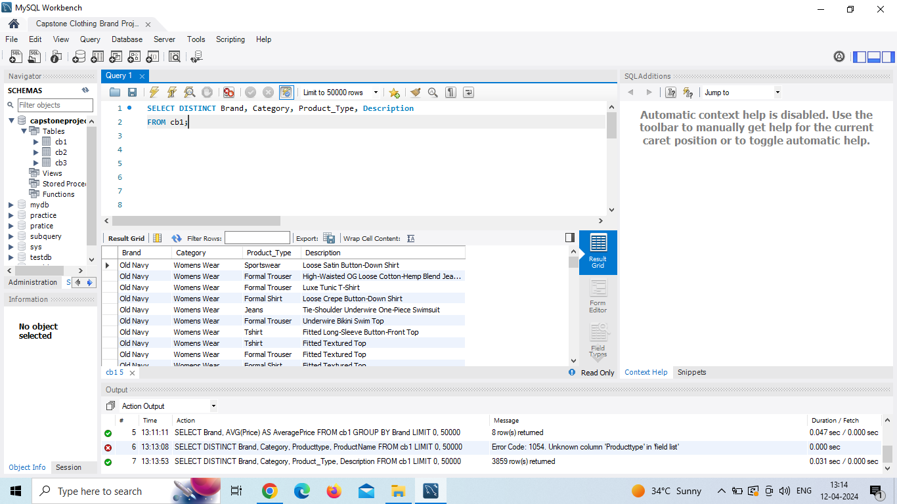

**Table**- 2

1 Write a query **Order Rows by Material Type in Ascending Order .**

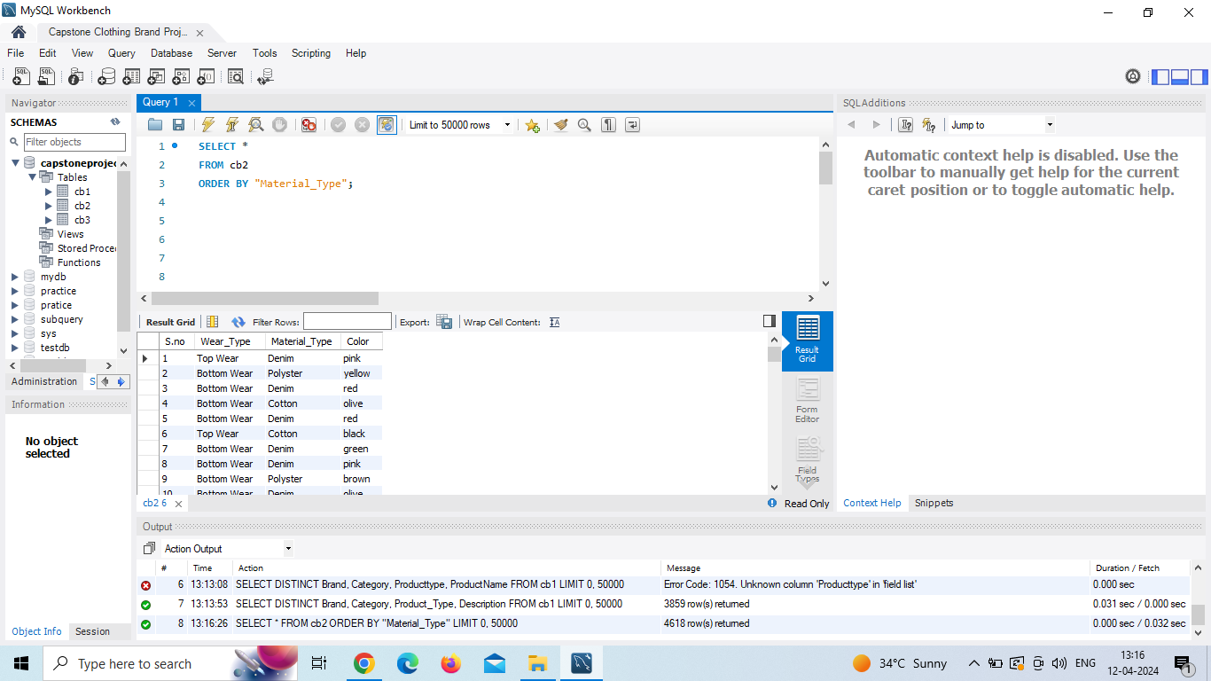

3. **Write a query to Retrieve the Top 30 Most Expensive Products by Weartype**:

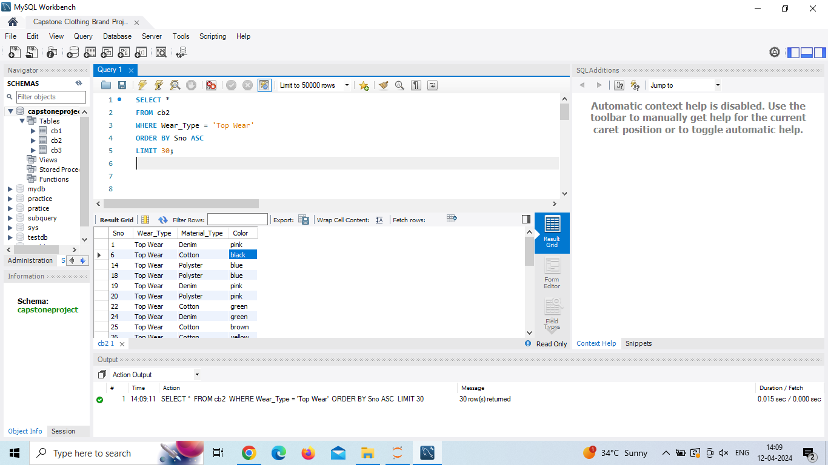

4. Write a query to **Find Products with Similar Colors**.

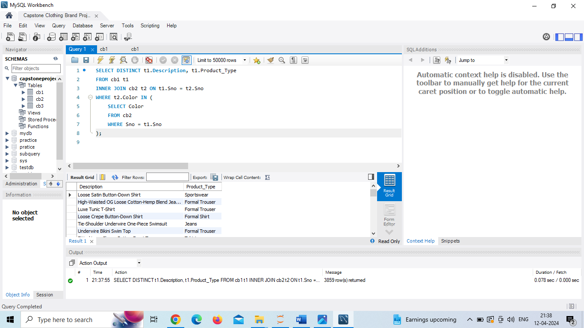

5. Write a query to **Calculate the Total Price for Each Material Type**.

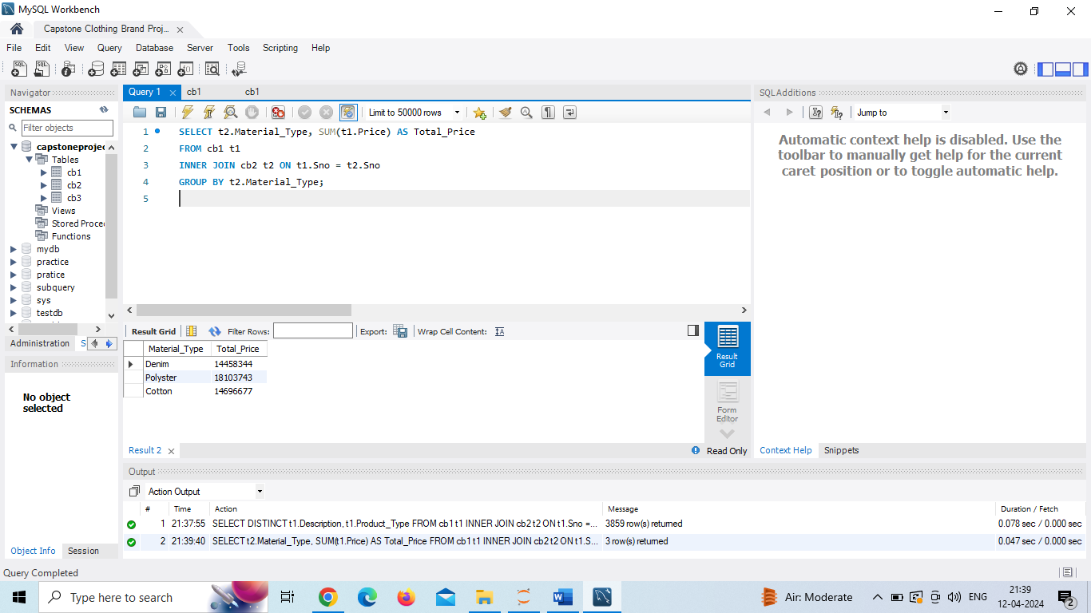

Table – 3

1 Write a query to **Order Rows by Return Time in Ascending Order.**

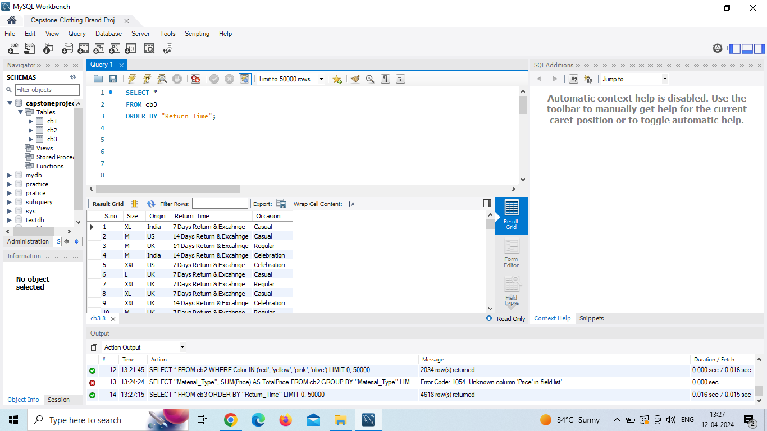

**2** Write a query to find distinct country of origin .

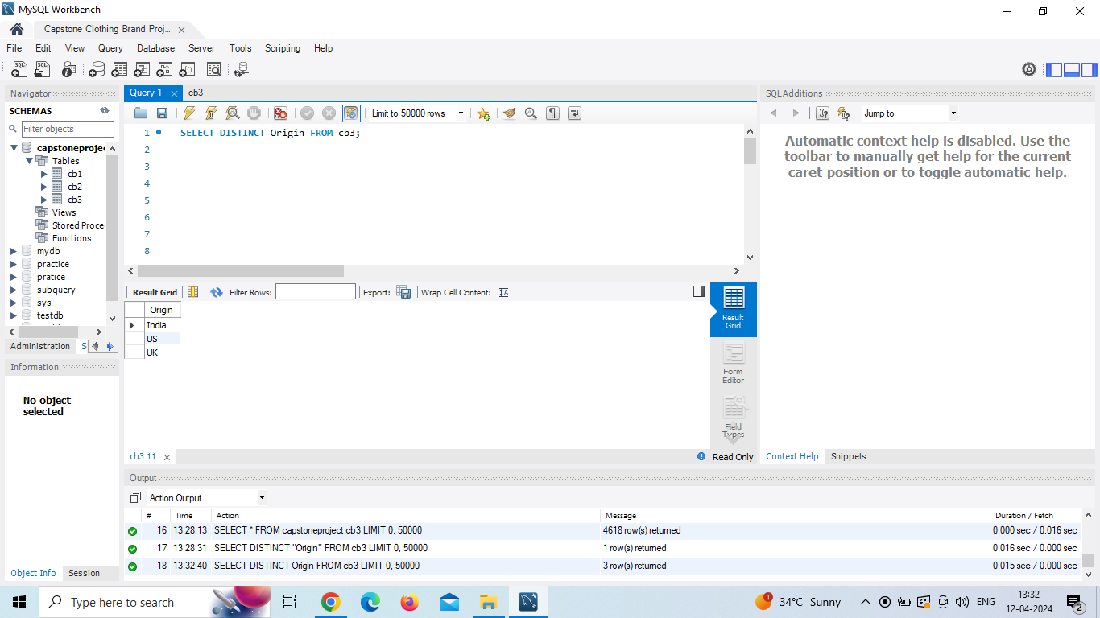

**3** Write a query to **Calculate the Average Return Time by Country of Origin**.

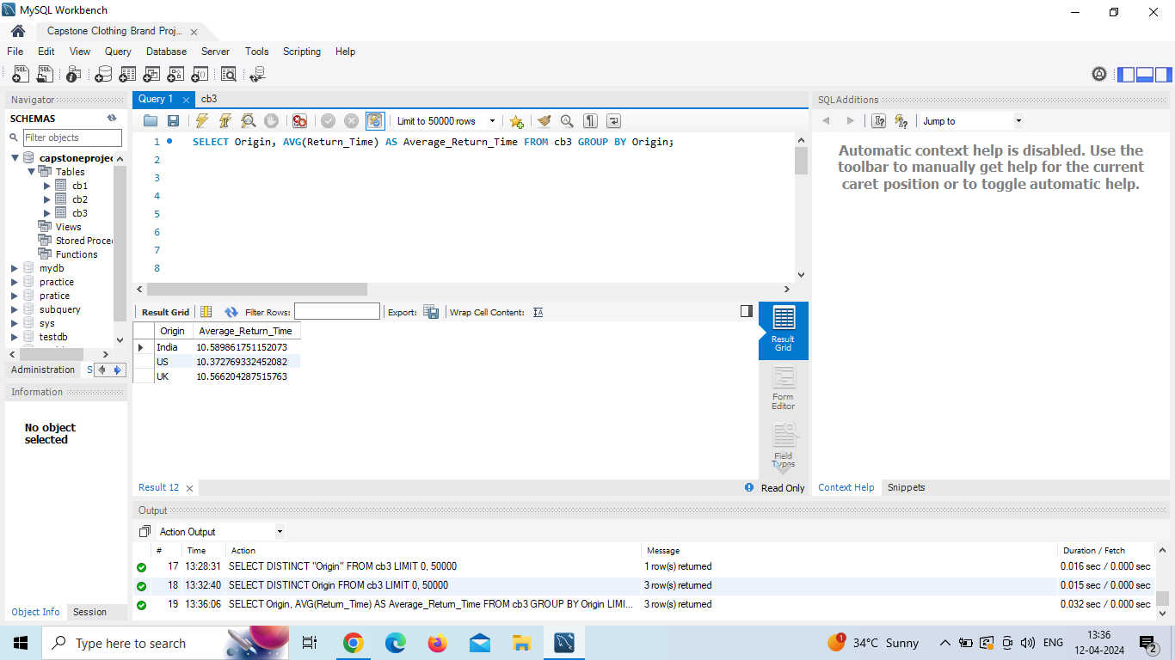

**4** Write a query to **Find Occasions with High Return Times.**

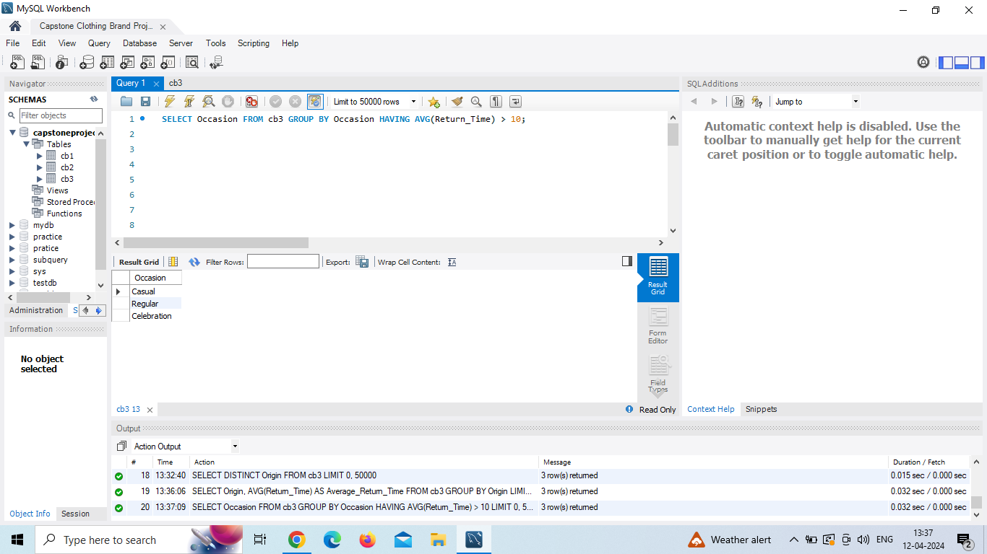

**5** Write a query to **Retrieve Products with Multiple Sizes (Size1, Size2, Size3, Size4)**:

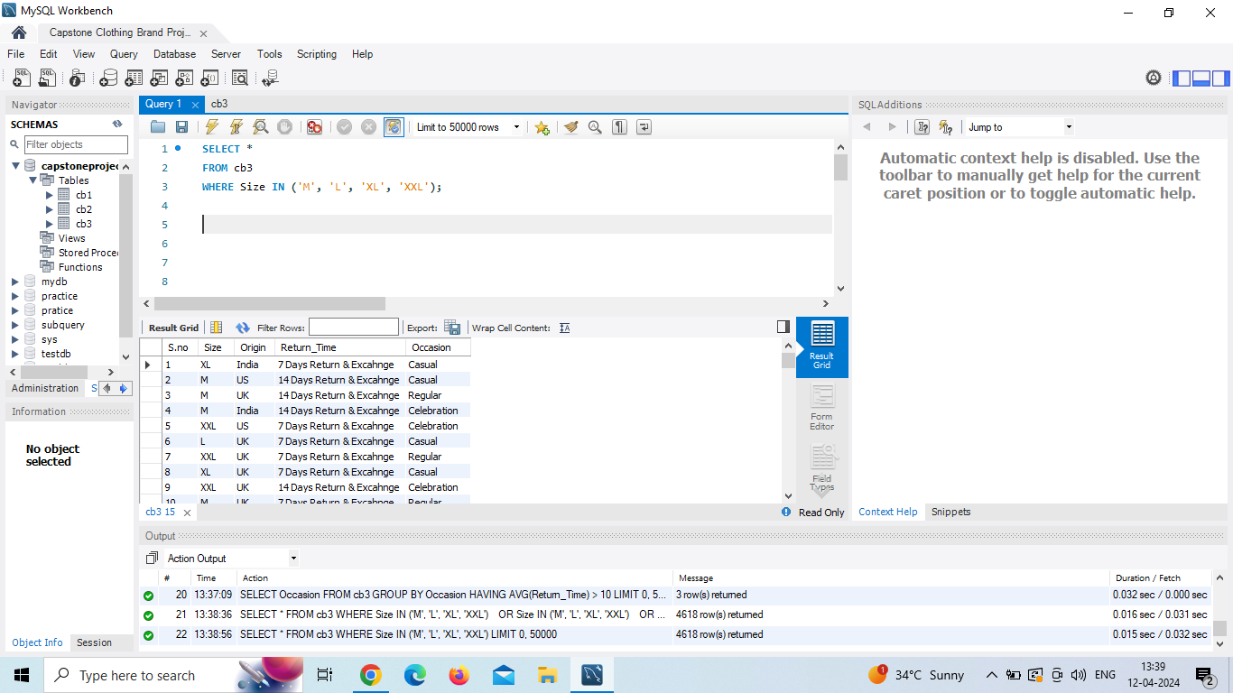

**Joint Queries-:**

1 Write a query  find Brandname, Category , Producttype ,ProductName  with a **listed price greater than the average listed price** in table 1.

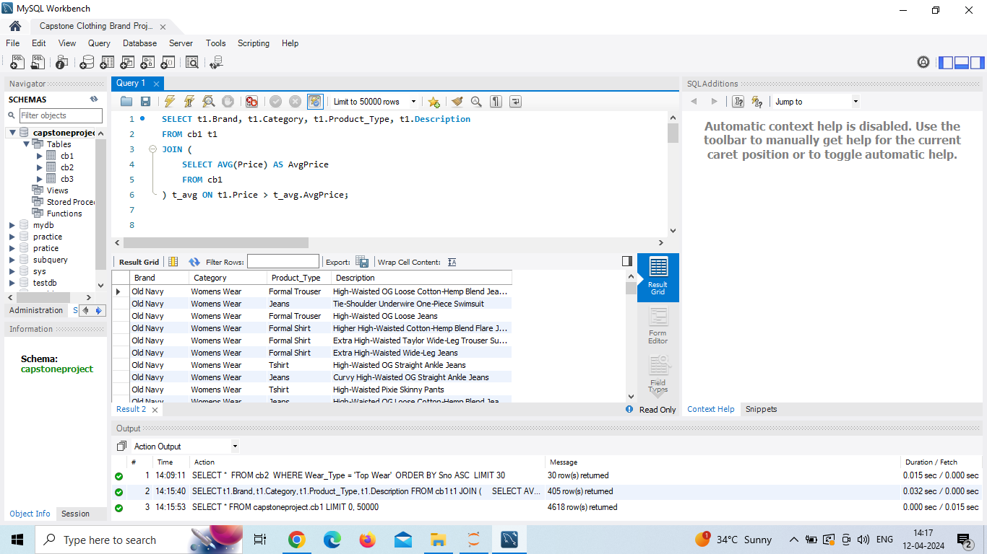

2 Write a query to list all Brandname, Category , Producttype ,ProductName   along with their corresponding **color information** from Table2

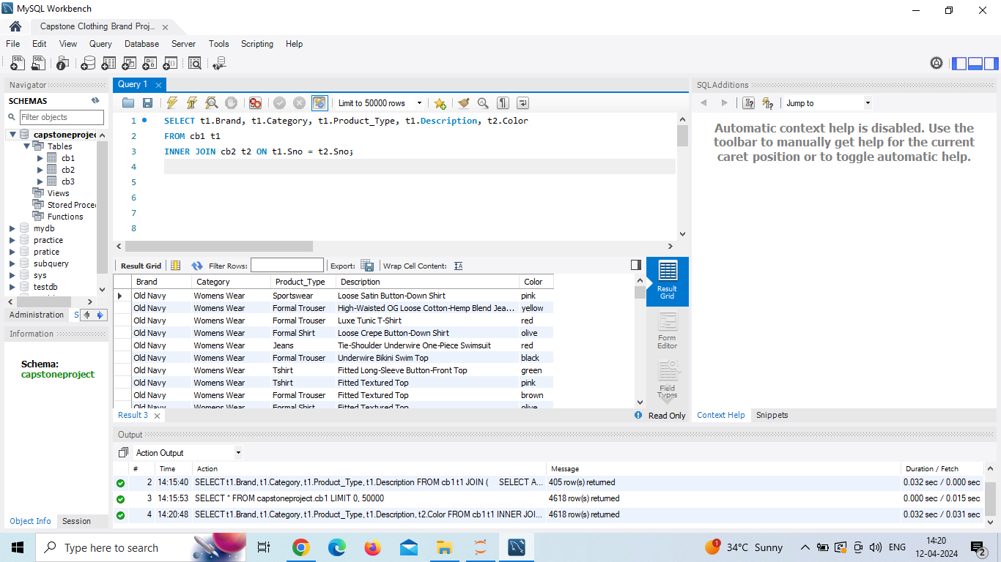

**4** Write a query  to find products with a Product name, **material type** that matches the **most common material type** in (use table1 and table 2)

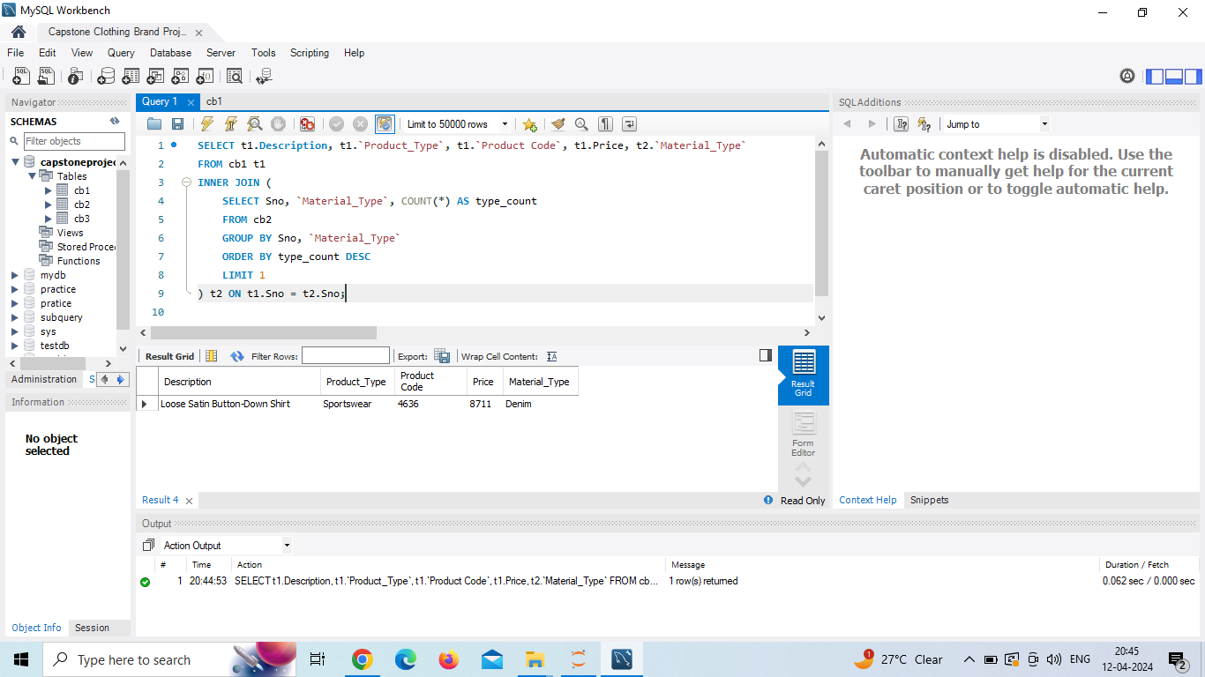

**5**  Write a query   to list all products  Weartype , Material type  along with their corresponding **sizes** from   (use table 2 and table 3)

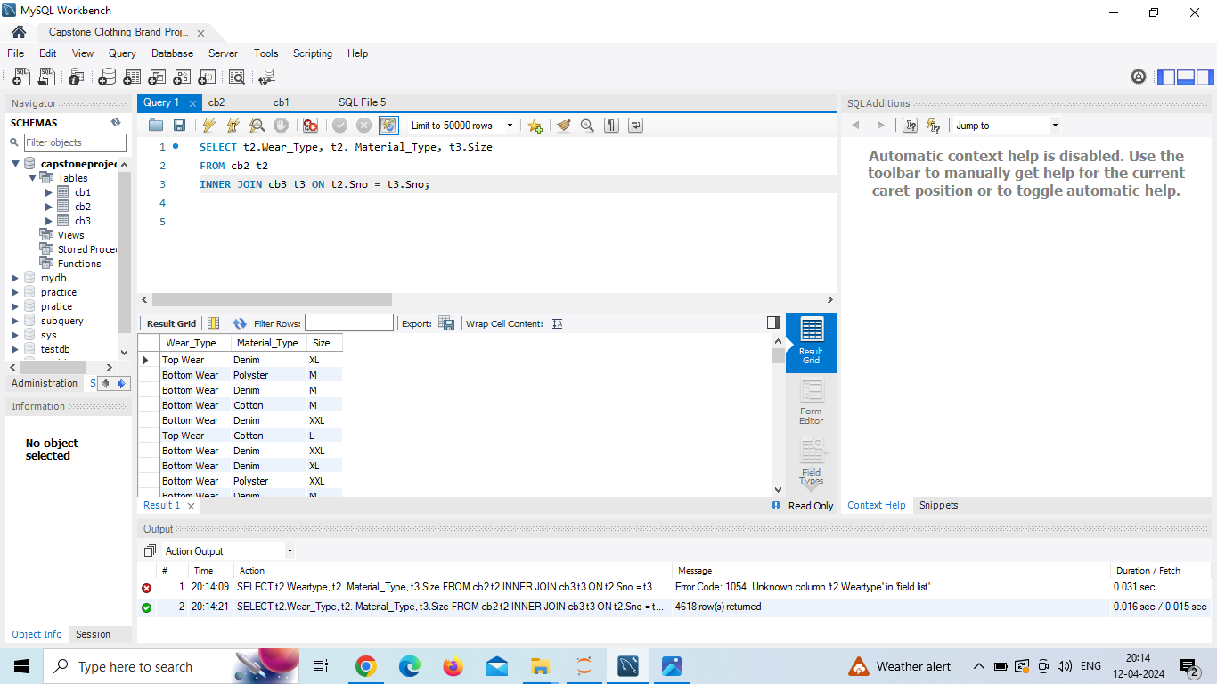

**6** Write a query  to find the **average return time** for each product type (use table1 and table 3)

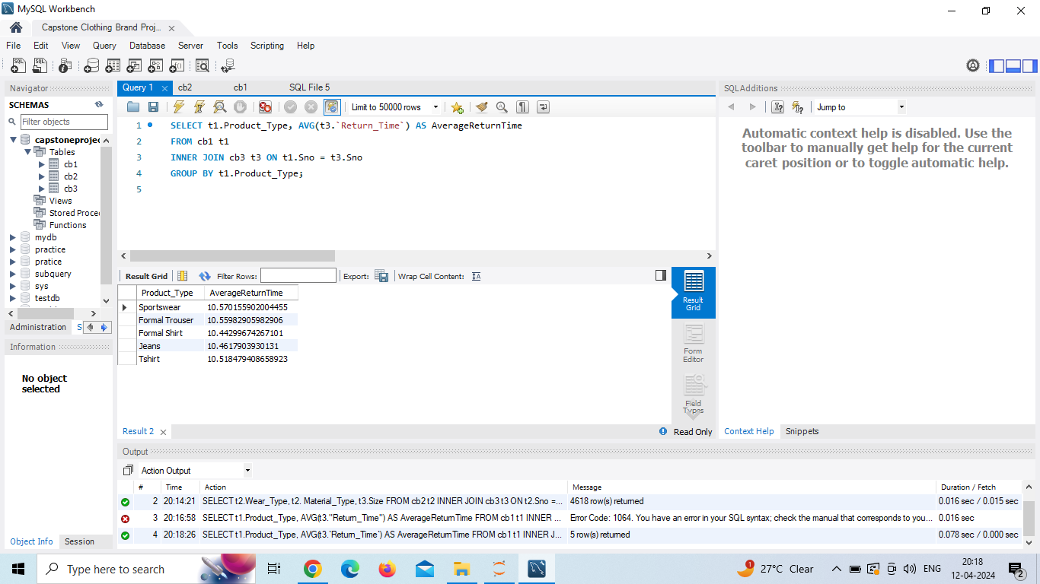

**7** Write a query to find Country of origin, return time ,occasion of each product type .

(use table 1 and table 3)

